**Food Image Recognition from that showing Food Items**

**PEOJECT DETAILS**

**In this project using deep neural network and pretrained model VGG16 , food is recognised from different categories. Rough dataset given by the reference paper author is used which even has bounding boxes. All the necessary preprocessing operations are performed to recognize the food data and based on food; dietary information is provided.**

**As we don’t have correct dataset, we used random values of dietary details (calories, fats etc). In this project we have used UECFOOD 100 dataset for training deep neural network. In this project there is detection and recognition of single food is present in future we can even go for multiple food recognition.**

**There are below important steps used ,**

1. **Uploading dataset to our Model**
2. **Preprocessing on selected dataset**
3. **Train deep neural network +VGG16**
4. **Plot the training performance graph for deep neural network and VGG16**
5. **Recognize the food from given dataset images or any own images**

**In this Application Python 3.7.0 is used and below python libraries are used to implement as**

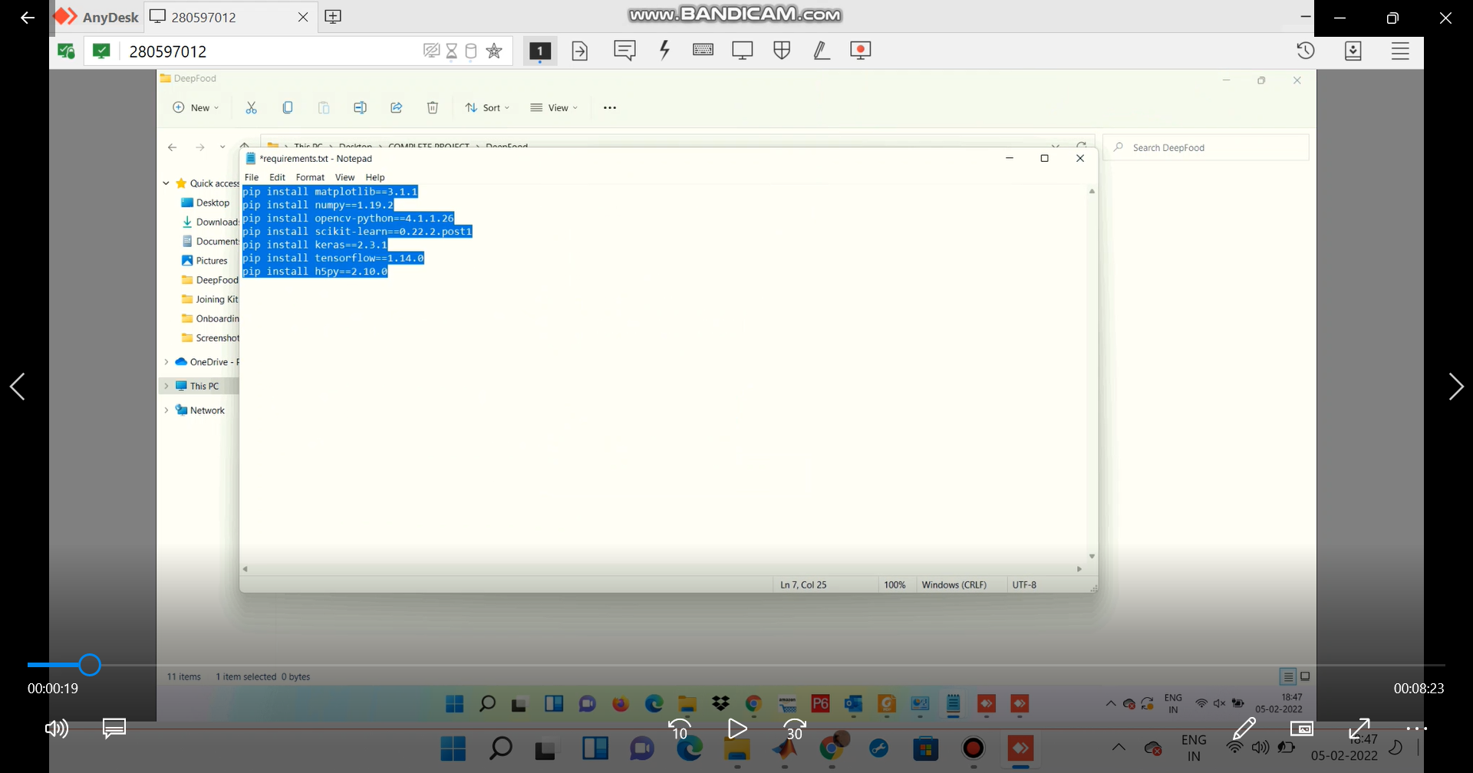

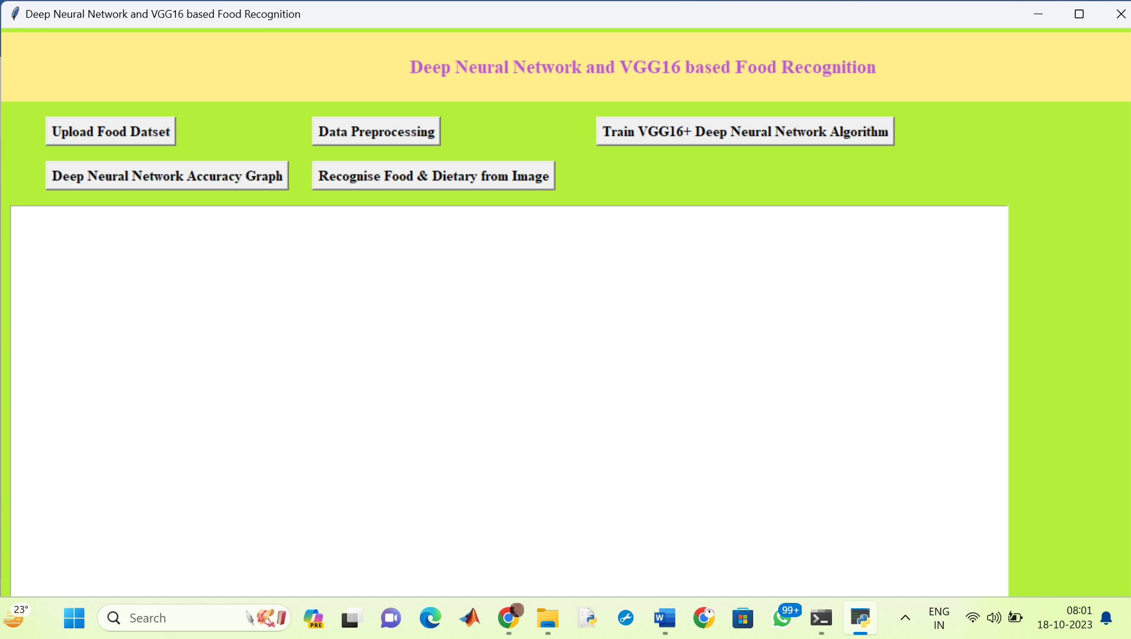

**Fig. GUI prepared for food recognition using Tkinter Library in python**

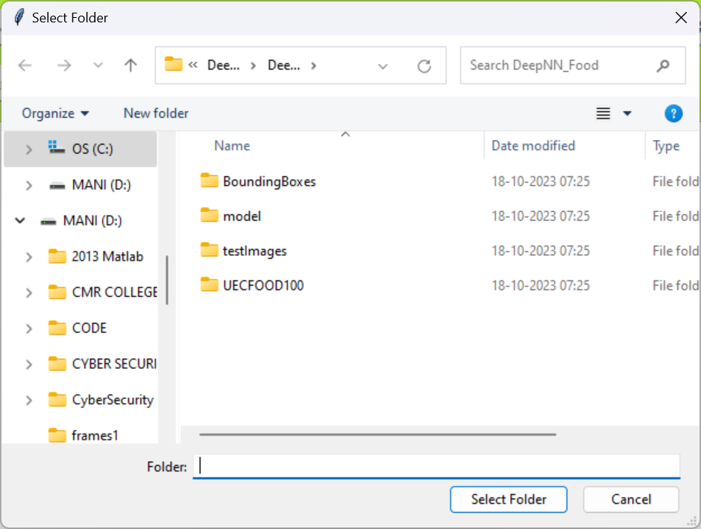

**From user need to select dataset**

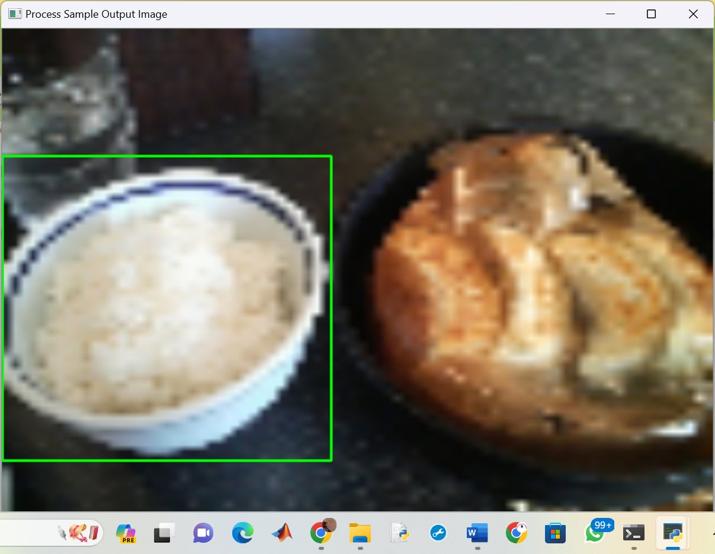

**After preprocessing the image , bounding box is applied to food data from image**

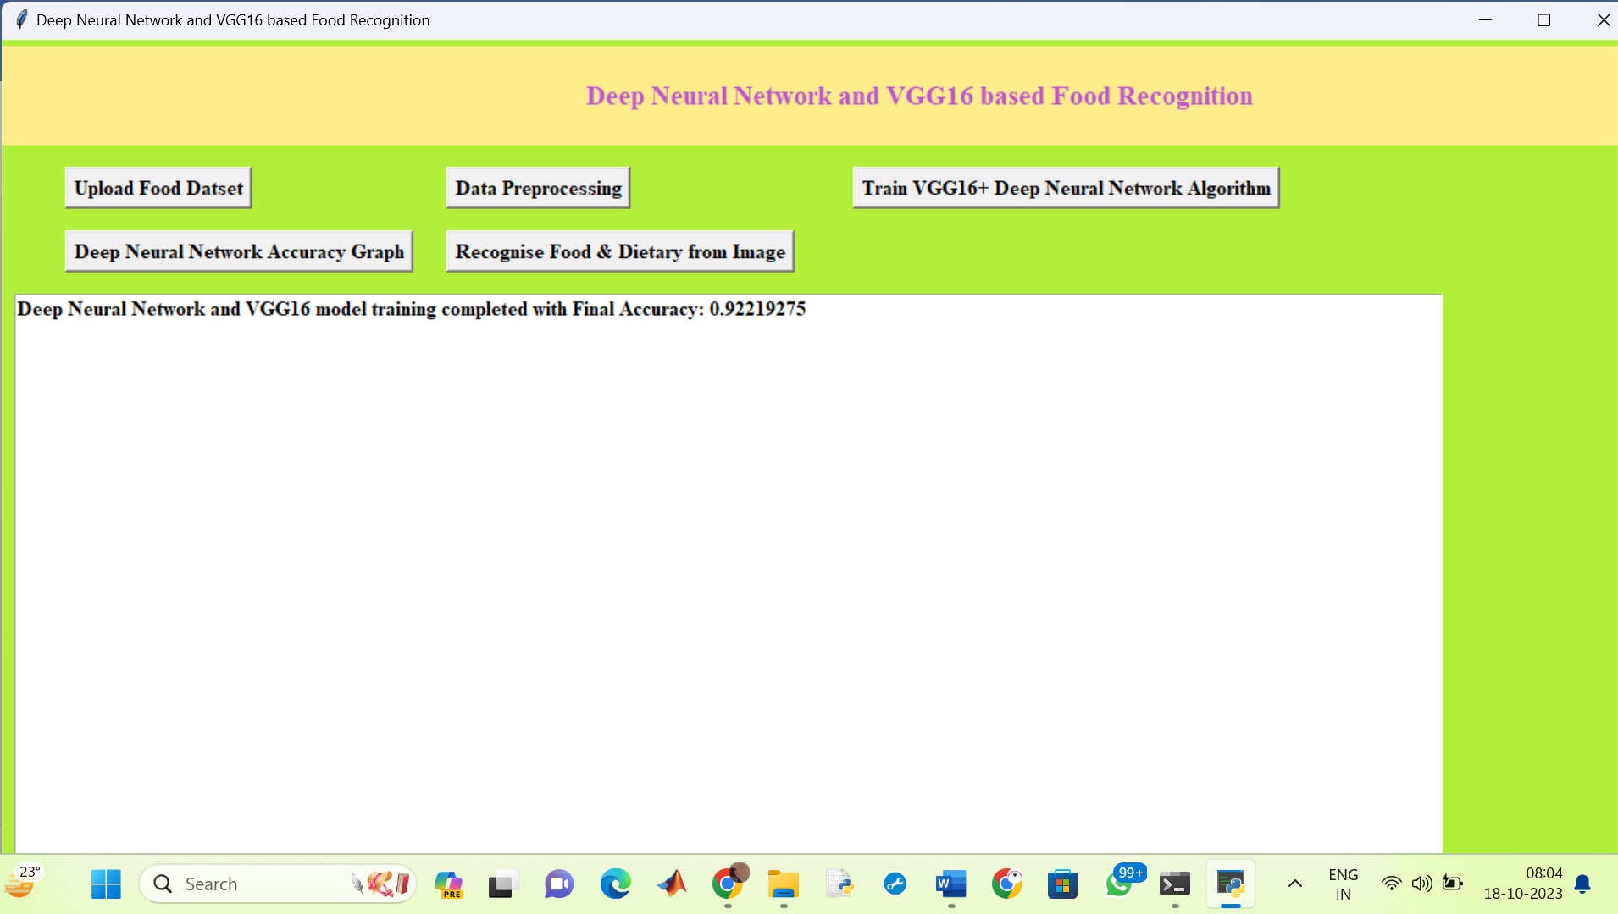

**Fig. Training Accuracy obtained is 92.2193 %**

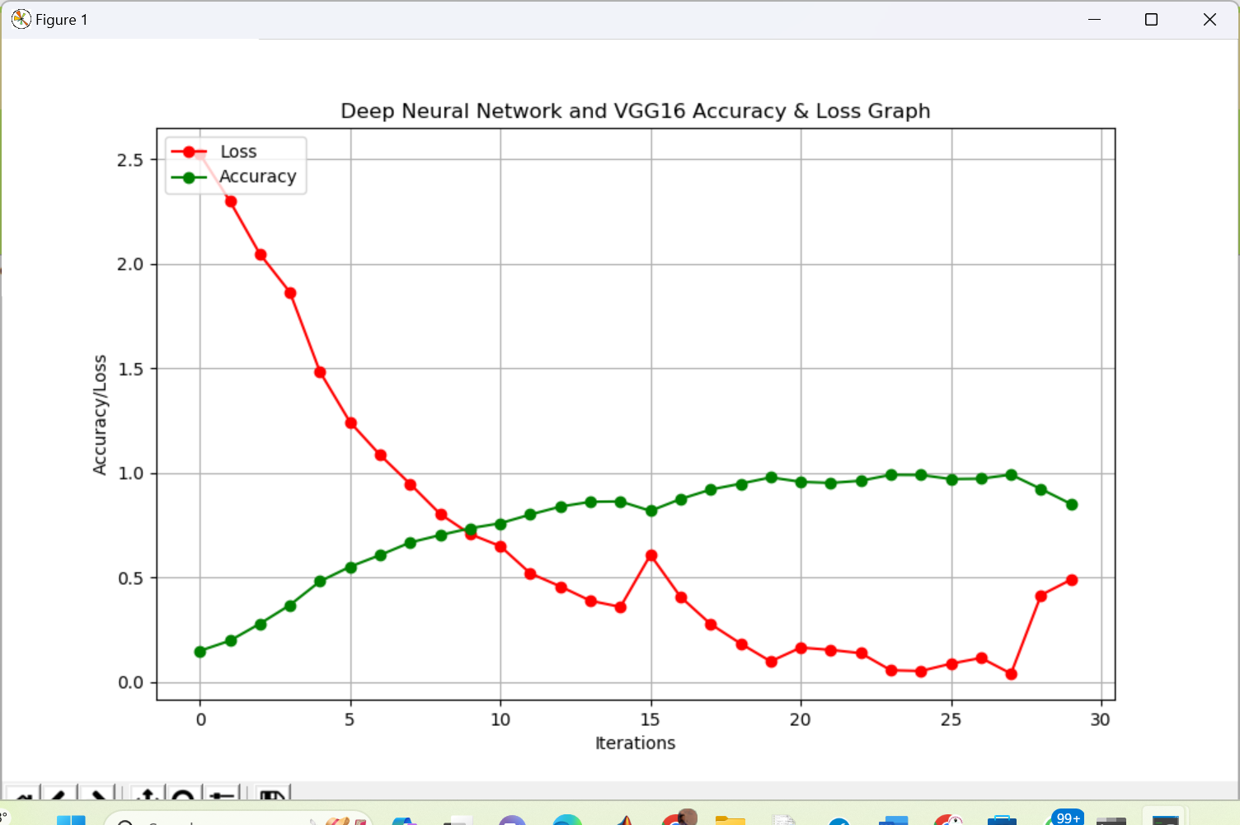

**Fig. Performance graph plotted for training accuracy and loss**

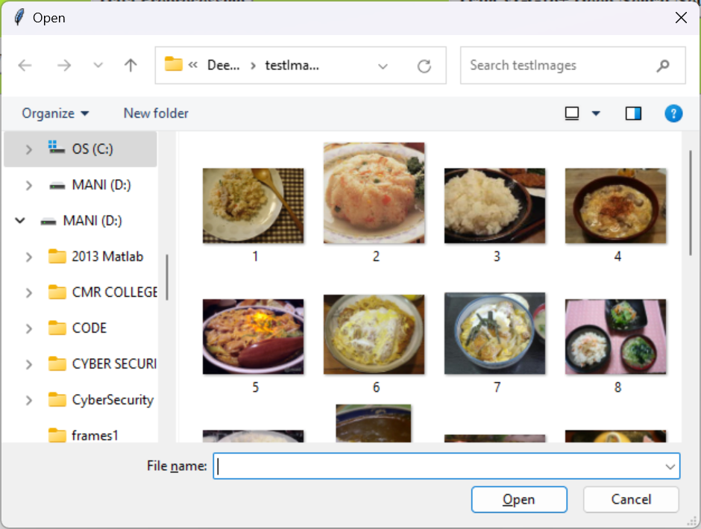

**Fig. selected image from test image folder**

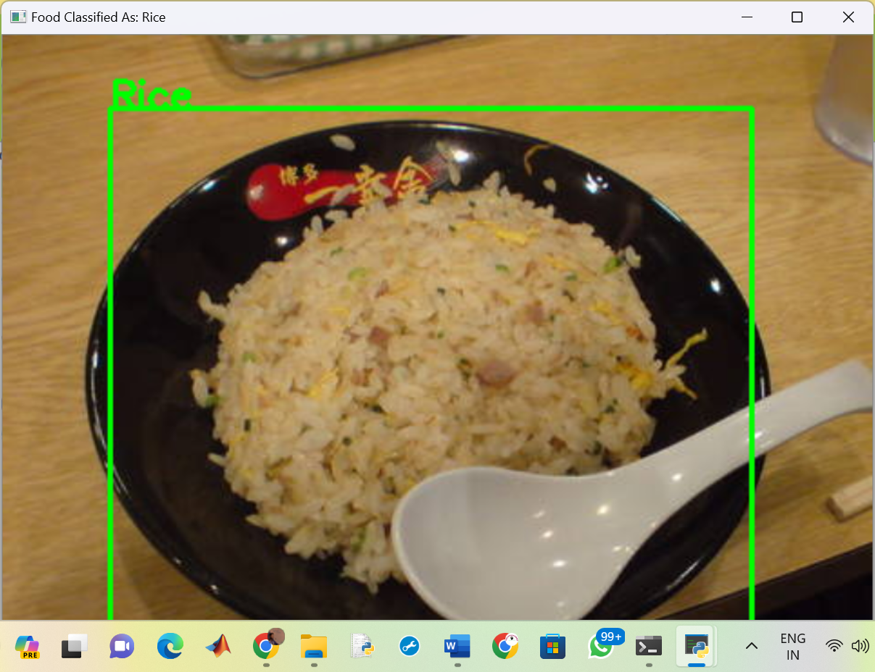

**Fig . food recognised as Rice**

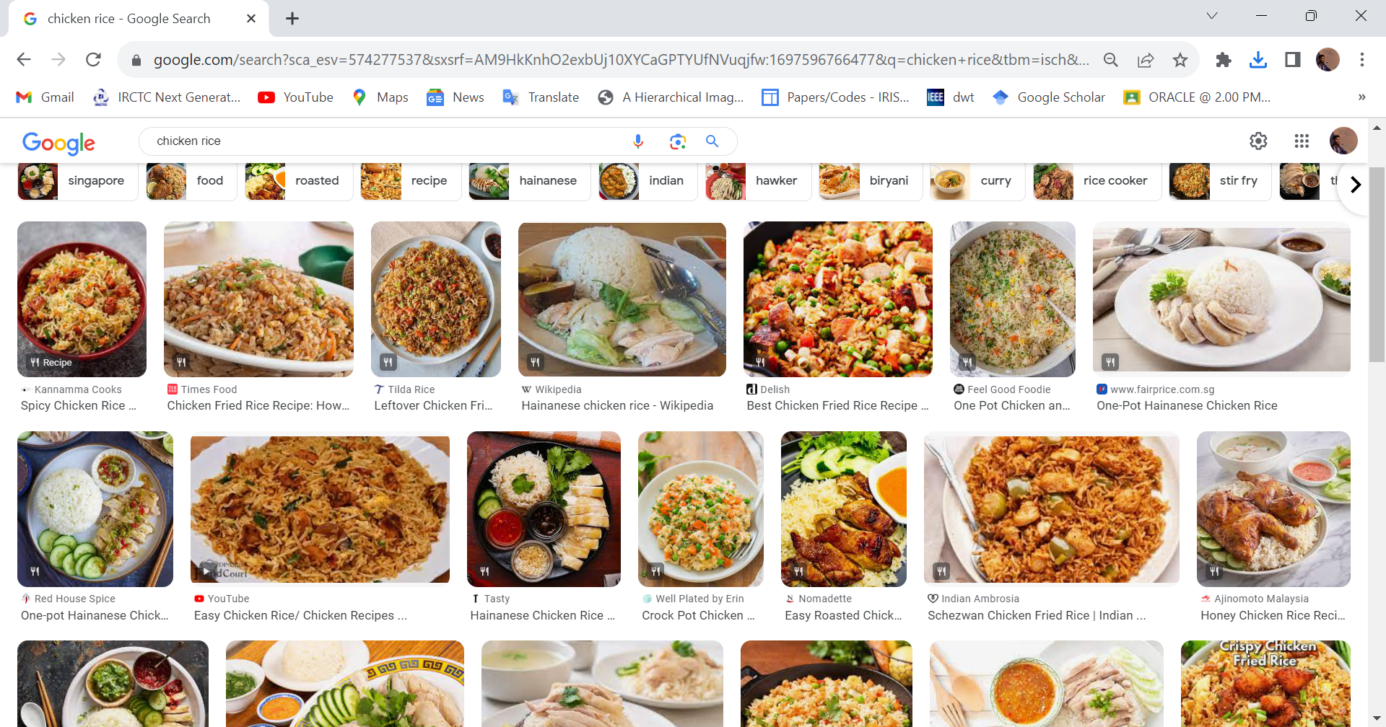

**Fig. Tested images from google for food recognition**

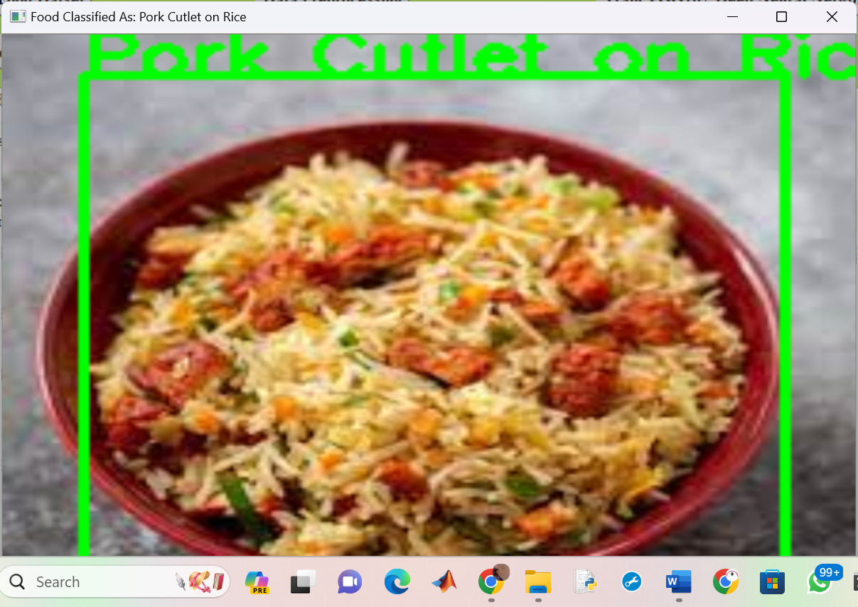

**Food recognised as Pork cutlet on rice**

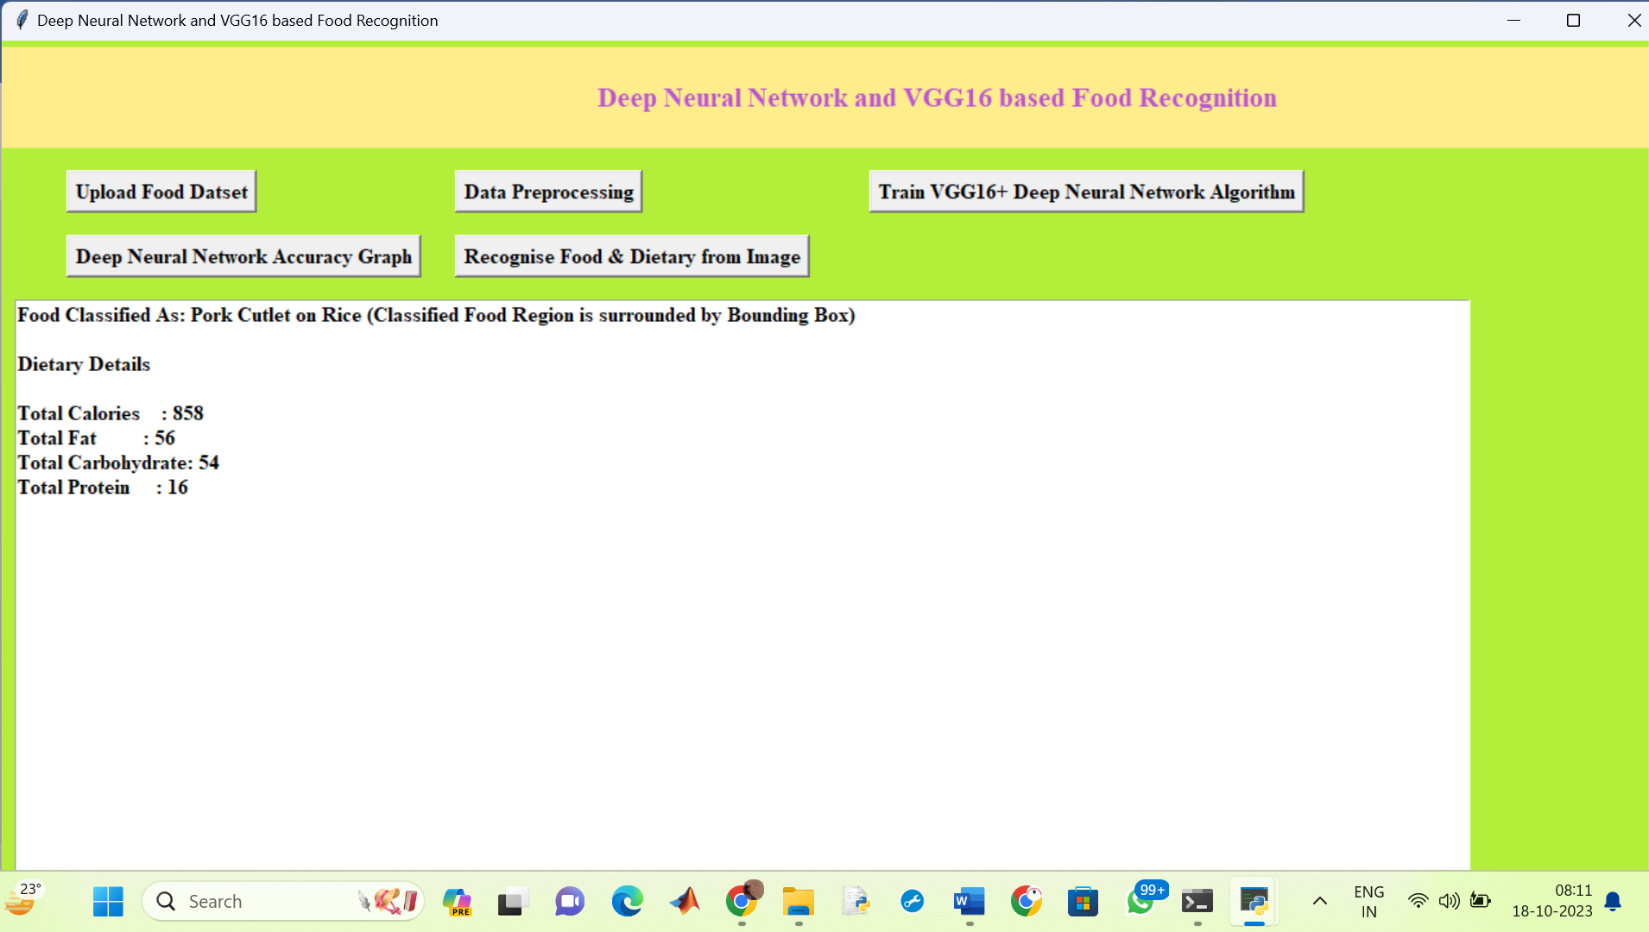

**Dietary information given**

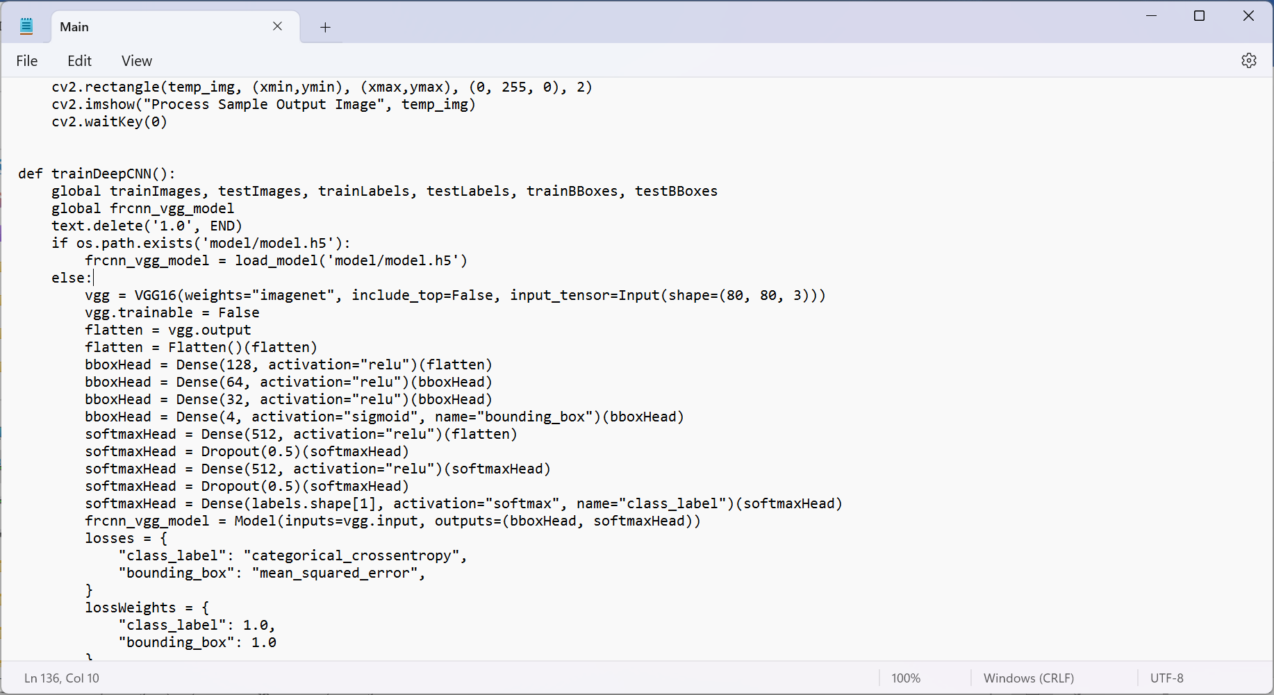

Fig. The deep neural network layers are as shown above and even pretrained VGG16 is also used for better accuracy